EXERCISE
(GUI Application – ReadOnly code)

Lesson 1:
1. Design the program window with the following interface and save with name as Nhanvien.java:
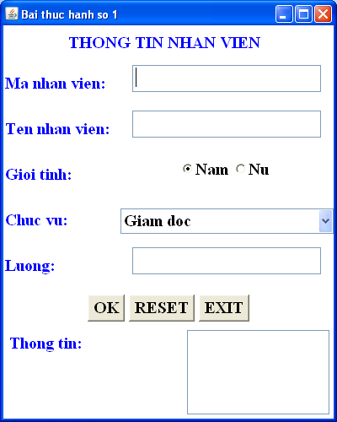
2. Programming the event on the program window in sentence 1 according to the following requirements:
- When click button RESET, TextFields are set null.
- When click button EXIT, the program window will close.
- When focus th TextField, the background of that TextField will turn pink, otherwise turn white.
- When the program lanches, Choice Chuc vu will add: Giam doc, Pho giam doc, Truong phong, Ke toan, Nhan vien, Bao ve.
- When choosing 1 position in Choice Chuc vụ, TextField Luong is set as following:

+ Giam doc: 10000000
+ Pho giam doc : 7000000
+ Truong phong: 6000000
+ Ke toan: 5000000
+ Nhan vien: 4000000
+ Bao ve: 2000000

- When you enter employee information and click the OK button, all employee information will be transferred to the List Thong tin.

Lesson 2:
1. Design the program window with the following interface and save with name as Dinhdang.java:
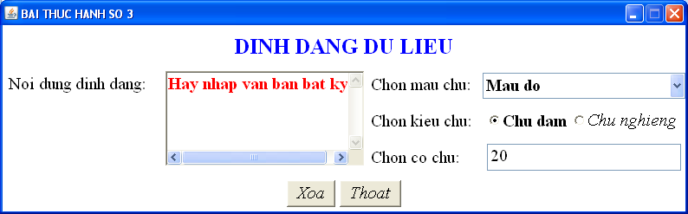
2. Programming the event on the program window in sentence 1 according to the following requirements:
- When click button Thoat , the program window will close.
- When focus th TextField, the background of that TextField will turn pink, otherwise turn white.
- When the program window lanches, button Xoa disabled. When text size is not null and is number, button Xoa enabled.
- Choose a color in Choice Chon mau chu, text Noi dung can dinh dang will be changed.
- Choose CheckBox Chu dam or Chu nghieng, text Noi dung can dinh dang will be changed as Bold or Italic.
- Input a integer number for TextField Chon co chu and click Enter, text Noi dung can dinh dang will be changed the size of text.

